How to Assign a User to a Campaign

Once you have logged in, go to **Management -> Campaigns Management**

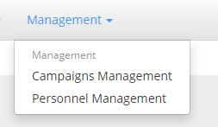

From the available list under selected status **RUN** select the Campaign you would like to assign the user to.

You can select the campaign by clicking any of the following info: **ID**, **Description** or **Overview**.

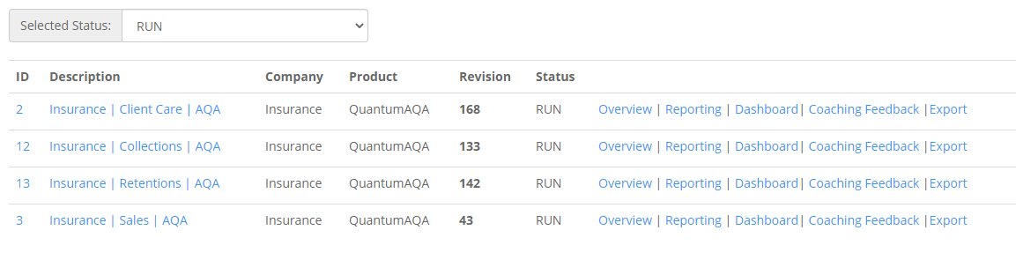



This will take you to the Overview of Campaign page

On the **Overview** Page, select the **Assign Users** button

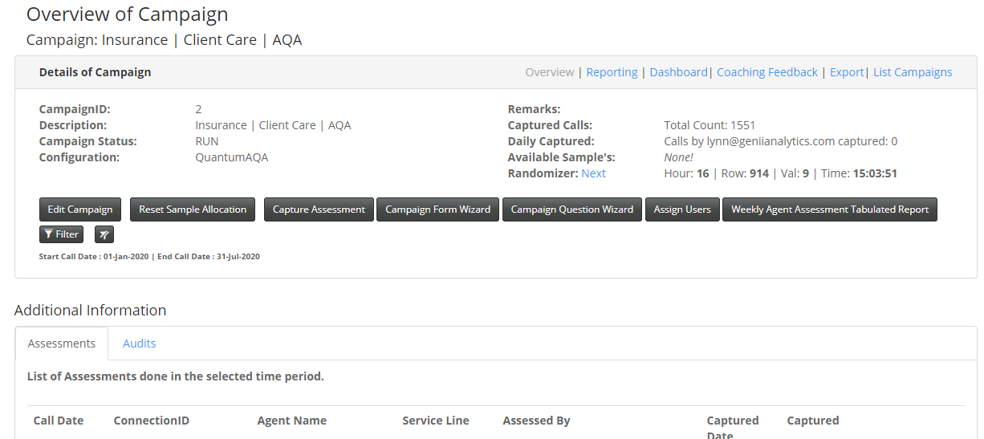

You will be taken to the page below, which is a list of users who have access to the app and which campaigns they have access to.

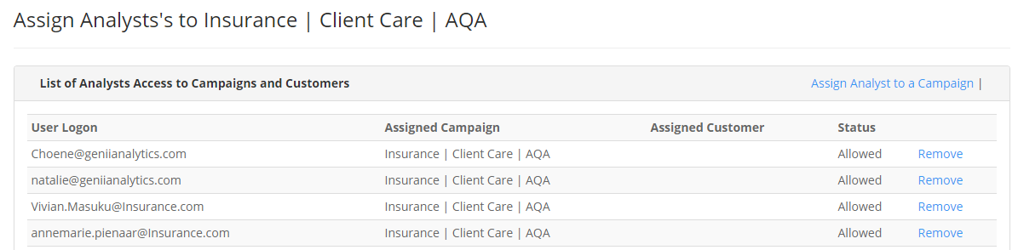

On this page select **Assign Analyst to a Campaign.**

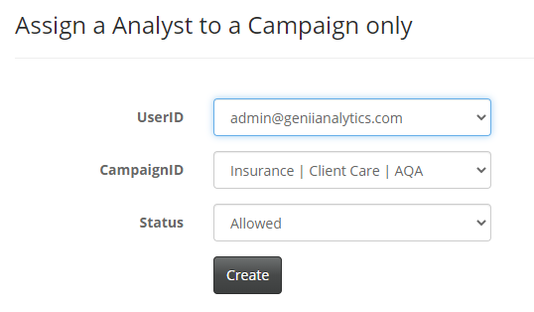



The UserID and CampaignID lists are in alphabetical order.

You will search for and select the user on the **UserID** dropdown.

You will search and select the campaign he/she will be assigned to on the **CampaignID** dropdown.

The **Status** should stay on Allowed

Once your selections are made select **Create**, and the person will be assigned to the new campaign.

Note: if you can’t find the user in UserID, please send a mail with the person’s details, Email and Full Name, to [appsupport@geniianalytics.com](mailto:appsupport@geniianalytics.com) so that we can create the person.